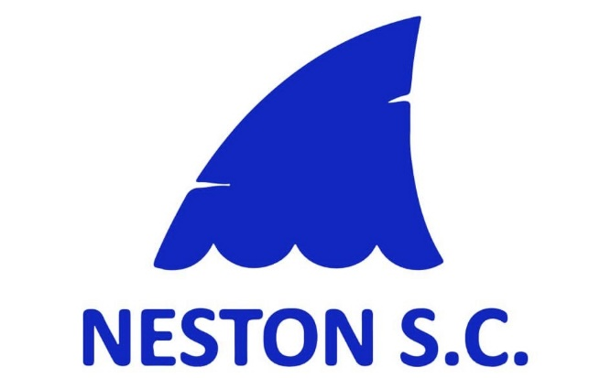
Code of Conduct – athletes under 18.
Taken form Wavepower – also available at https://www.swimming.org/swimengland/wavepower-child-safeguarding-for-clubs/
Updated 14th March 2026
This code is something that you as an athlete should refer to in relation to your rights as an athlete, the respect you should expect but also that which you demonstrate to other members, what is expected of you in terms of listening and being listened to and your behavior as a member of the club. As a member of our club, you have the right to:
- Feel safe and know how you can raise concerns.
- Be listened to.
- Be involved and contribute towards decisions within the club or activity.
- Be respected and treated fairly by every member of the club.
- Feel welcomed, valued and not judged based on your race, gender, sexuality, faith, ability or any other relevant characteristic.
- Be encouraged and developed with our help and support.
- Be looked after if there’s an accident or injury and have your parents/guardians/ emergency contact informed, where appropriate.
As a member of our club we expect you to:
- Be aware of Wavepower and adhere to relevant guidance.
- Adhere to the Swim England regulations, Code of Ethics, Club Constitution and rules.
- Listen to your coach or teacher, behave responsibly and speak out when something isn’t right.
- Never leave the premises (at either training or a competition) without agreeing it you’re your coach, teacher or team manager first. This is just as important for our adult members as well as those under 18.
- Make it to training and competitions on time and if you’re running late, let a member of the club know.
- Make your coach or teacher aware if you have any difficulties attending training or competitions.
- Bring the right kit to training and competitions.
- Take care of equipment and premises as if they were your own.
- Support and encourage your team-mates.
- Respect volunteers and competitors at competitions.
- Respect the committee members, coaching and teaching team and volunteer helpers at all times.
- Get involved in club decisions, it’s your sport too.
We expect certain standards of behaviour from our members. By becoming a member of the club and therefore agreeing to this Code of Conduct you agree to:
- Follow the rules of the club, squad or activity at all times.
- Respect and celebrate differences in the club and you will not discriminate against
- anyone else on the grounds of age, gender, race, sexual orientation, faith, ability, or any other relevant characteristic.
- Understand that the use of abusive or inappropriate language, bullying, physical violence or any other behaviour which hurts others will not be tolerated by the club.
- Respect the privacy of others especially in the changing rooms.
- Not use any mobile device, at any time, in the changing areas.
- Report any concerns you have about someone taking photographs or footage of others in the changing areas.
- Report any incidents of abuse, bullying or other unacceptable behavior to the Welfare Officer, even if you’re just a witness.
Breaches of this Code of Conduct will result in disciplinary action being taken against you by the club committee and any behaviour which may be a criminal offence will be reported to Police and any other relevant authority, by the club.

